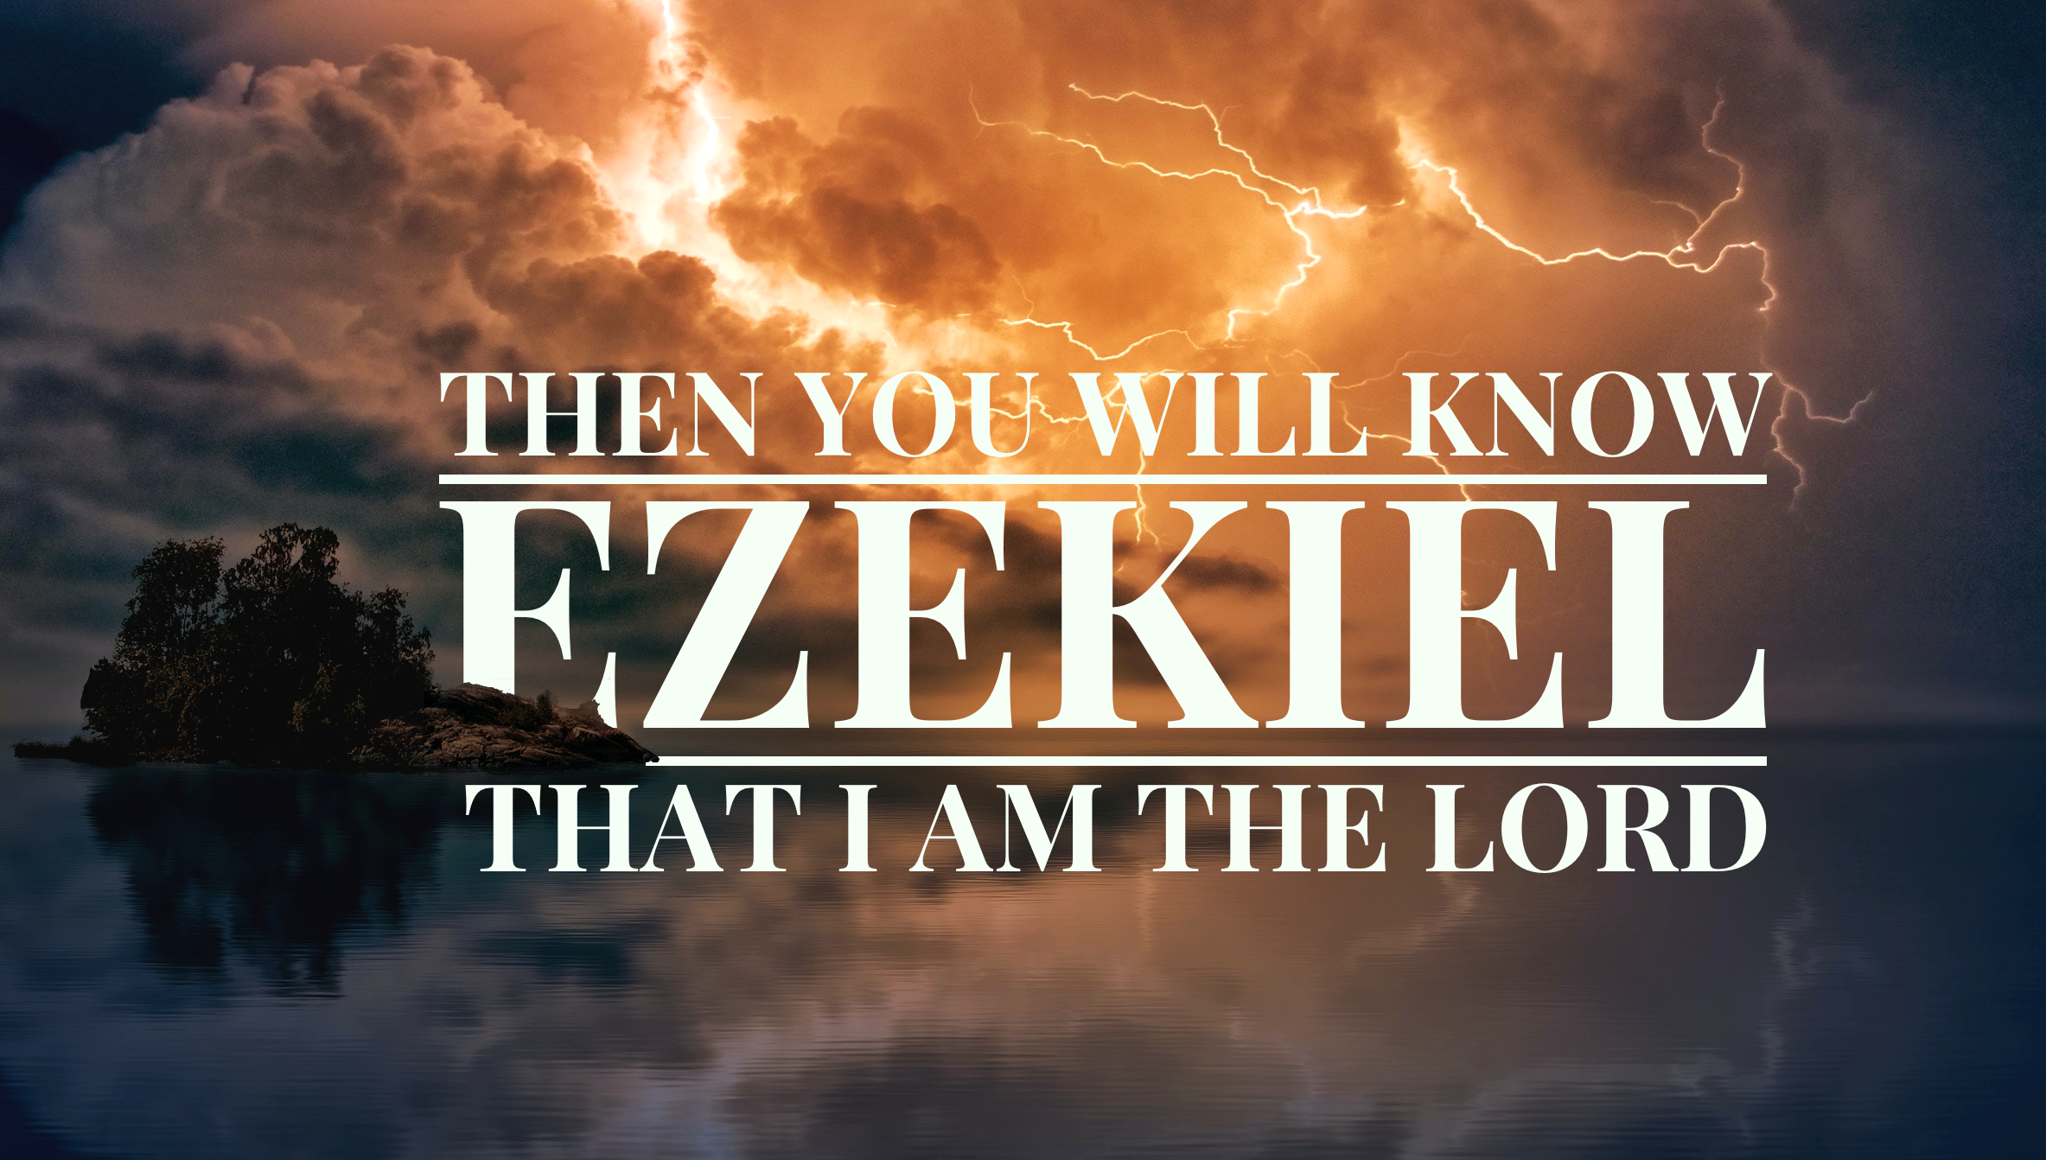

Ezekiel
Group Member Booklet

Ezekiel: Then You Will Know that I am The LORD

“Then you will know that I am the LORD” is a refrain repeated over 70 times throughout the book of Ezekiel. The idea of “knowing God rightly” sits at the very heart of the prophet’s message. Ezekiel proclaimed the word of the LORD, in oracles and evocative street theatre, during one of the darkest and most tumultuous periods in Israel’s history—the fall of Jerusalem and exile to Babylon.

From Ezekiel we learn the root cause of this national crisis was Israel’s abandonment of the Lord. They had forsaken their knowledge of him as the one true God by worshipping foreign gods. They had forsaken their knowledge of him as the one true light by resorting to bloodshed and depravity. And they had forsaken their knowledge of him as their one true hope by placing their trust in foreign powers. So God brought his just judgment against them. This judgment was not simply punitive but revelatory—that clarity might come from calamity. For even as Israel had forgotten the Lord, he had not forgotten them. Though his glory would depart the temple, it would do so in order to join his people in a foreign land. And though that empty temple would eventually be razed to the ground, Ezekiel delivers a glorious vision of God’s promise to restore the nation, and to rebuild and refill the temple so that he might dwell in their midst once again.

Ezekiel is a book that puts “knowing God rightly” at the centre of existence. Is there anything more important than getting that right? When we do, what do we find? Ezekiel unveils for us a glorious & challenging answer. We hope you grow in your knowledge and love of God as a result of your study of this grand book of the Bible.

Historical Background
Ezekiel’s life spanned a period of significant political upheaval in the world. He lived through the decline of Assyrian domination only to see the rise of an all-powerful Babylonian Empire. Some important dates are listed below (dates are often approximate.)

931 BC | The Kingdom of Israel is divided into the Northern Kingdom of Israel & Southern Kingdom of Judah
722 BC | Northern Kingdom is conquered by Assyria
627 BC | Jeremiah is called to be a prophet
622 BC | Ezekiel is born
612 BC | Assyrian capital Nineveh falls to Babylonians
609 BC | Death of Josiah King of Judah (Last good king!)
605 BC | Babylon conquers Egypt (Battle of Carchemish)
605 BC | Judah becomes a vassal state (with Jehoiakim as king).  Small deportation of Israelite elites incl. Daniel; (see Daniel 1:3) to Babylon.
597 BC | Jehoiakim rebels against Babylon, leading to the 1st major deportation to Babylon (10,000 people including Ezekiel).  Jehoiachin installed as new puppet king of Judah (See 2 Kings 24.14).
596 BC | Zedekiah replaces Jehoiachin as puppet king
592 BC | Ezekiel called to be a prophet at 30 years of age
587 BC | Zedekiah rebels and seeks military alliance with Egypt, leading to the sacking of Jerusalem (incl. temple destroyed) and the 2nd major deportation of exiles to Babylon.
572 BC | Ezekiel’s days of prophesying conclude.

Who was Ezekiel?
We don’t know a great deal about Ezekiel, outside the book of Ezekiel itself. He was the son of Buzi, a priest. Ezekiel was in training to be a priest at the Temple in Jerusalem when he was taken captive in 597 BC. He was 30 years old when called to be a prophet of the Lord to the exiles in Babylon. He was married but his wife died at the time of the fall of Jerusalem (see Ezek. 24:18).

It appears that the exiles lived approx. 75 kms south of Babylon on the Euphrates river, at Nippur (see map). They would have seen its famous hanging gardens, its massive fortifications and magnificent Ishtar Gate.

Life for the exiles was not exactly a prison-like experience. They had some restrictions but also significant freedom to build homes, produce crops, worship and maintain communication with those left back in Judah.

Did Daniel & Ezekiel know each other?
It is difficult to imagine that Daniel & Ezekiel did not know each other. Daniel went to Babylon with an initial deployment of the best and brightest of Israel (in 605 BC). Ezekiel, because he had trained as a priest, was deported during the first major deportation in 597 BC.

Although they both were prophets of the exile, they had vastly different ministries (in fact the book of Daniel features in the Writings section of the Hebrew Scriptures with other wisdom literature like Proverbs and Job), rather than being included among the Prophets as it is in our Old Testaments. Daniel was more involved in the political realm, moving amongst kings and courts, and looked forward to the political restoration of Israel. Ezekiel functioned as the pastor to the exiles (a tough crowd indeed), and anticipated Israel’s religious restoration including a new temple, law and covenant.

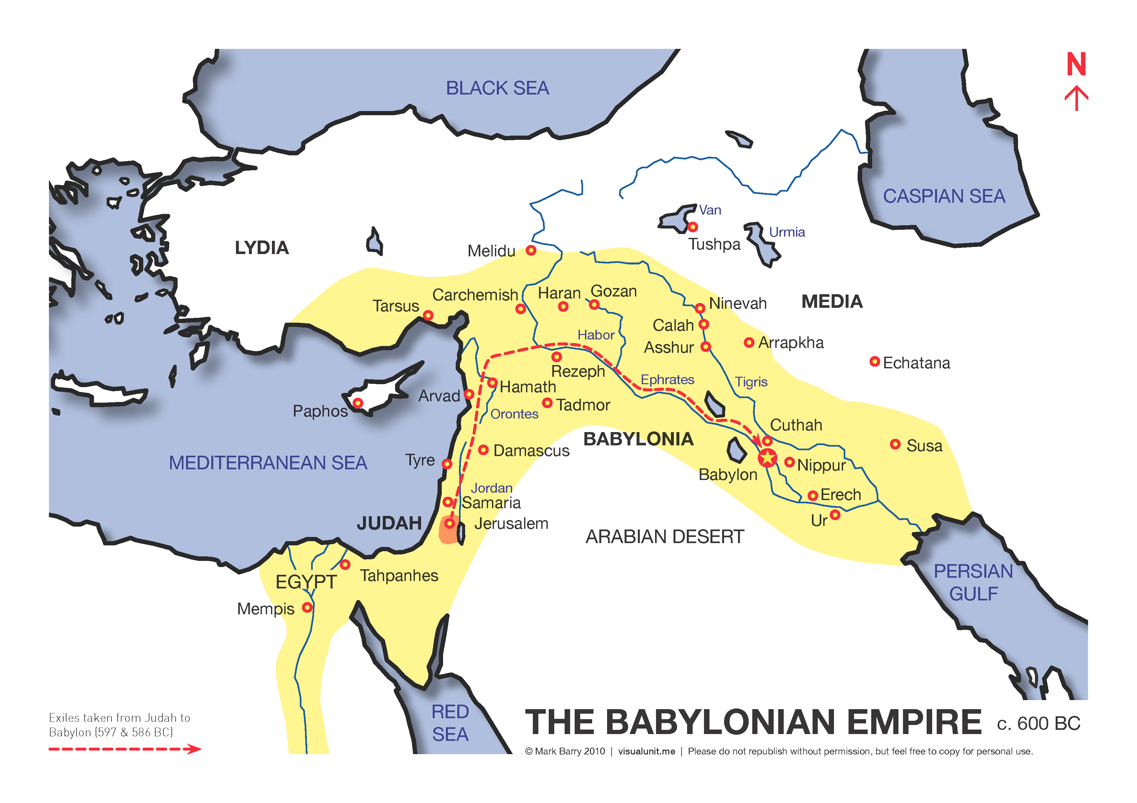

Study Timetable

We’ve prepared these growth group studies to use following the Sunday message. Here’s a suggested timetable for their use (but feel free to use them in the way that works best for you).

Sunday Sermon Date | Passage | Mid-week (growth group) | What?
Leader Session/Special Teaching Night:
Wednesday 21 April
Sun 25 April | Ezekiel 1:1-28 | 26-29 April | Study 1: The Lord who Goes
Sun 2 May | Ezekiel 4:1-5:13 | 3-6 May | Study 2: The Lord who Calls
Sun 9 May | Mother’s Day | 10-13 May | Case study: The Problem of Exile
Sun 16 May | Ezekiel 8:1-18;  10:1-22 | 17-20 May | Study 4: The Lord against Religion (Israel)
Sun 23 May | Ezekiel 28:1-16 | 24-27 May | Study 5: The Lord against Success (the Nations)
Sun 30 May | Special Sunday | 31 May to 3 June | Case study: The Problem of Bad Leaders
Sat 6 June | Ezekiel 33:1-33 | 7-10 June | Study 6: The Lord who Forgives
Sun 13 June | Ezekiel 36:22-37:14 | 14-17 June | Study 7: The Lord of Life
Sun 20 June | Ezekiel 42/47 | 21-24 June | Study 8: The Lord who Returns
Winter school holiday break

Study 1: The Lord who Goes (Ezekiel 1)

Start
Are you optimistic about the future of the church? What makes you nervous? What makes you hopeful?

Share any feedback or take-home points from Sunday’s message.

Read
Ezekiel 1:1-28 then share your initial response with the group.

Think & talk
- In the first few verses Ezekiel tells us he is among the exiled Israelites by the Kebar River in Babylon. What does that tell us about the setting of the book?

- What particular doubts might the exiled Israelites like Ezekiel had about God, as they waited in Babylon?

- How do we know that Ezekiel’s vision is a glimpse of the glory of God? Why is it significant that God is on a throne with wheels?

- In what ways do you typically think of God? How does this vision of the glory of God expand or correct our own vision of God?

- Read Ezekiel 2:1-3:15. What is Ezekiel’s task and what will be the likely response among his people?

- What warning does Ezekiel 2 & 3 hold for us as everyday Christians, and as proclaimers of the good news about Christ Jesus?

Pray
Praise God for his awesome transcendence and his ready immanence, that he can rule over the universe and still be close to us.
Repent for when we’ve had an unduly small/low view of God, or have hardened our hearts towards his word.
Ask for soft hearts and willing spirits to worship God for who he is, and to take his words to heart and put them into practice.

Study 2: The Lord who Calls (Ezekiel 4/5)

Start
What is the oddest thing you’ve been asked to do by a friend, parent or boss?

Share any feedback or reflections from Sunday’s message.

Read
Ezekiel 4:1-5:13 and share your first thoughts with the group.

Think and talk
- In Ezekiel 3:16-27 Ezekiel is charged with the responsibility of warning the people of God’s impending judgment. What is odd about the way he starts this unpleasant task in chapter 4?

- His performance art is odd, but what is the point Ezekiel is trying to communicate? Is it drama for drama’s sake?

- The final sign-act in chapter 5 is just as graphic. What is it, and what does it signify?

- God is the God who calls; what does Ezekiel’s calling teach us?

- What is at the heart of God’s displeasure for the people of Israel (see 5:5-9)? Are there any parallels to us today?

- How does this passage expand or change your understanding of the God we know?

Pray
Praise God for his words of warning, even when they come in unusual ways.
Repent for when you’ve not given a good account of our God and Saviour to people in your midst.
Ask for both a willingness to obey God, even when it’s uncomfortable, and a desire to be a light for him to those around you.

Case Study: The Problem of Exile

Start
Finish this statement: “Nothing says home like…”

Watch
“Exile” by the Bible Project [5mins]
(https://bibleproject.com/explore/video/exile)

Think & talk
- Ezekiel is written in the context of Israel’s exile in Babylon. What do you understand is involved in the concept of “exile”?

- Explore the following passages (together or in groups). Though the circumstances differ, what do they all have in common?

Passages | What exile? | God’s grace?
Genesis 3:14-24
Genesis 4:8-16
Genesis 16:1-10
Genesis 45:25-46:6, Ex 3:7-10

- Read Psalm 34, which David wrote while he was on the run from Abimelech. David was in a time of personal exile, pursued by enemies. How would you characterise his response:
a. to God?
b. towards himself?
c. to the world?

- Think about times in your own life when this sense of exile has been acute. What other sources (positive or negative) have you been tempted to look to for comfort and security? What happens when you put your hope in these sources rather than God?

- Read 1 Peter 1:1-9. How is the concept of “exile” used to capture the Christian life? How should it shape our everyday actions and decisions?

Pray
Praise God for his commitment to us while we are in exile, and his commitment to bring us home to be with him.
Repent of times when you have failed to trust God while in exile, or have alternatively looked to anything and everything other than God to make life here comfortable.
Ask him to help you make the most of the difficulties of life in exile, that they might refine our faith, and make us yearn for our heavenly home with God.

Study 4: The Lord against Religion (or Israel, Ezekiel 8/10)

Start
What are some of the common complaints about organized religion that you hear? Do you think they are valid at all?

Share any feedback or take-home points from Sunday’s message.

Read
Ezekiel 8:1-18 and share your opening observations.

Think & talk
- As the elders sat with Ezekiel in Babylon, he is taken on another visionary tour—a God’s eye view—of the temple in Jerusalem. What does he see there that is so troubling?

- God has described himself as a jealous God (see v.3, Exodus 20:5, Deut 4:24). How can jealousy be appropriate for God, when it is usually inappropriate for humans? Why would it cause God’s presence to leave?

- It has been said that “the sin of world generates God’s grief and anger, but the sin of God’s own people generates his jealousy”. Do you agree? Would you want to add anything to this statement?

- Read Ezekiel 10:1-2; 15-19. What appears to be going on in these scenes?

- If this passage is primarily about failed religion, what specific application does it hold for us today?

- How does this passage expand or change your understanding of the God we know?

Pray
Praise God for his jealous desire for our devotion and worship.
Repent for when of the times when you’ve had split loyalties, even when engaged in “worship”.
Ask that God might help you to follow him only, in the ways he has set out, and with all your heart.

Study 5: The Lord against Success (or the nations, Ezekiel 28/29)

Start
Have you ever lived in another country? What did you like about life there? What was unusual?
If you could be any other nationality, which would you choose, and why?

Share with the group your recap from Sunday’s message.

Read
Ezekiel 28 and discuss your first thoughts.

Think & talk
- In chapters 25-32 God turns from announcing judgment upon Israel to declaring judgment against the nations that surround her. What seems to be the specific crime of Tyre & the King of Tyre in chapter 28?

- What does Ezekiel pronounce will be the outcome of the King of Tyre’s pride?

- What other reasons does God give for announcing judgment upon the nations surrounding Israel? See 25:1-3; 8-9, 12-13, 15-16?

- What special reason does God give for judgment upon Egypt in 29:1-9, 16? What lessons might that have for us in modern times?

- The prophecy against Sidon (28:20-26) speaks quite pastorally about Israel. What hope is there in their hopeless situation?

- “Then they will know that I am the LORD” is a repeated refrain in the book, but especially in these chapters (see 25:7, 11, 14, 17, 26:6, 28:23, 26, 29:6, 9, 16). What will they/we know about God through his judgment of the nations? How does this expand or change in the New Testament?

Pray
Praise God for his judgment, that stands against evil, especially evil that is borne of pride, wealth and power.
Repent of times when you have trusted in worldly success or worldly things rather than tying your ongoing security to trust in Christ.
Ask that God might help you to rightly fear his judgment, to trust him completely, and that he might extend his saving grace to people around you.

Case study: The problem of Bad Leaders (Ezekiel 34)

Start
What are some typical outcomes when a team doesn’t have effective leadership?

Read
Ezekiel 34:1-31 and discuss your initial impressions.

Think & talk
- How does the shepherd metaphor work in this passage, and what have the shepherds done?

- What will the consequences be for the shepherds?

- How personally does God seem to take their offences (trace the use of “I will…” in v.11-16). How exactly will he intervene personally (see v.23-24)?

- We’ve seen the judgment upon the shepherds/leaders; are there any consequences for the sheep themselves?

- How do we see the promises of this passage fulfilled in the New Testament (see John 10:7-18)?

- How does this section inform what we know about God?

Pray
Praise God that Jesus is a Good Shepherd, who lays down his life for all who follow him.
Repent of any times you have used your position of leadership to take advantage of others.
Ask for God to help you listen to the Good Shepherd’s voice.

Study 6: The Lord who Forgives (Ezekiel 33)

Start
Have you ever wished for a fresh start at something? When and why?

Read
Ezekiel 33 and share your opening observations with the group.

Think & talk
- With the fall of Jerusalem in full view, what complaint do the Israelites have against God?

- How does God answer the charge that he is unjust? What else can we say about his judgment from this passage?

- How does the second half of this passage (v.21ff) reveal that the people did not heed that call? How is the fall of Jerusalem a turning point for the people?

- Turning from wickedness and idolatry back to God is the way to avoid judgment. Why do people not do this more readily?

- How does the New Testament describe this turning around as the key to salvation? See Ephesians 2:1-10 and 1 Thessalonians 1:3-10.

- How does this section inform what we know about God?

Pray
Praise God for the opportunity to turn to avoid judgment.
Repent of any unconfessed sins now.
Ask for God to fill you with ongoing desire to walk with him, to love him more than we love sin and pride, and for humility to always come before him in penitence and faith.

Study 7: The Lord of Life (Ezekiel 36/37)

Start
Have you ever experienced a dramatic reversal of fortune, either for good or for bad? Would you attribute that reversal to God in any way?

Read
Ezekiel 36:22-37:14

Think & talk
- What is the great reversal of fortune that chapter 36 depicts?

- Perhaps unsurprisingly, God will restore the people for the sake of his holy name. How was God’s name honoured by Israel’s judgment, and how can it be honoured by their restoration?

- How is God’s name glorified today?

- What does it mean for God to put a new heart and a new spirit within his people?

- How does Ezekiel’s vision of the valley of dry bones add to the hope of chapter 36?

- How does this section change or expand what we know about God?

Pray
Praise God for his glory, his holiness, his salvation, his gift of life, his powerful word and his life-giving Spirit.
Repent for when you have either ignored God, or operated as though you were the centre of the universe, and even the centre of salvation.
Ask that God might move your heart, in the power of the Spirit, to live for him and obey him in every part of your life.

Study 8: The Lord who Returns (Ezekiel 42/47)

Start
What do you imagine heaven will be like? On what data or information did you base your answer?

Read
Ezekiel 42:15-43:12 and share you first thoughts.

Think & talk
- What does Ezekiel see in this latest vision? Why would it have meant so much to him?

- What is required of the Israelites if they are to experience the blessing of the presence and glory of God again?

- The exact temple in Ezekiel’s vision was never built, so it points to something else, something grander. How is Ezekiel’s vision of a new temple fulfilled (see John 2:18-22; Revelation 21:22-23)?

- Read Ezekiel 47:1-12. What is the significance of the river?

- How do we make sense of this river in our day and for the future (see Revelation 22:1-5)?

- How does this final look at Ezekiel change your knowledge of God? What aspect of the whole book has reshaped your view of God the most?

Pray
Praise God for our access to him through his Son. Praise him also for the abundant and perfect future that awaits us, should we trust in him.
Repent for when you have lost sight of eternity, and sought heaven’s blessings here on earth.
Ask Jesus to fill you with hope for the future, and contentment while we wait its glorious fulfilment.

Notes:

Notes:

